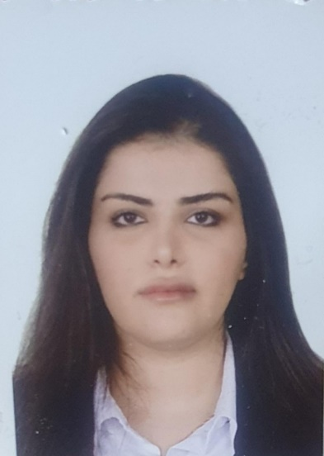

Name: Nada Eissa Beshet Radhi Al _eqaby
Date of Birth: 24_3_1991
Phone number :07739680402
Email:issanada28@gmail.com
Address: Baghdad,Zayona
Education: Bachelor in Translation from Alma’mon university college 2014, Master degree : Methods of Teaching English from Almustafa university College 2018
Training Courses and workshops : The Art of Etiquette and English terms in the ministry of financial
Profissional Experience: worked as lecturer (2020,2021)at Ibn Rushud university (English department) ,Al Bani University College (2022,2023) and Almansoor Univirsity

